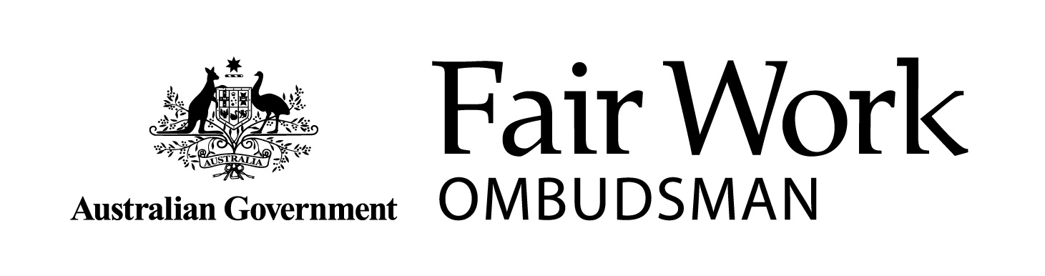 | Fair Work Information Statement
From 1 January 2010, this Fair Work Information Statement is to be provided to all new employees by their employer as soon as possible after the commencement of employment. The Statement provides basic information on matters that will affect your employment. If you require further information, you can contact the Fair Work Infoline on 13 13 94 or visit www.fairwork.gov.au.

►The National Employment Standards
The Fair Work Act 2009 provides you with a safety net of minimum terms and conditions of employment through the National Employment Standards (NES).
There are 10 minimum workplace entitlements in the NES:
1. A maximum standard working week of 38 hours for full-time employees, plus ‘reasonable’ additional hours.
2. A right to request flexible working arrangements.
3. Parental and adoption leave of 12 months (unpaid), with a right to request an additional 12 months.
4. Four weeks paid annual leave each year (pro rata).
5. Ten days paid personal/carer’s leave each year (pro rata), two days paid compassionate leave for each permissible occasion, and two days unpaid carer’s leave for each permissible occasion.
6. Community service leave for jury service or activities dealing with certain emergencies or natural disasters. This leave is unpaid except for jury service.
7. Long service leave.
8. Public holidays and the entitlement to be paid for ordinary hours on those days.
9. Notice of termination and redundancy pay.
10. The right for new employees to receive the Fair Work Information Statement.
A complete copy of the NES can be accessed at www.fairwork.gov.au. Please note that some conditions or limitations may apply to your entitlement to the NES. For instance, there are some exclusions for casual employees.
If you work for an employer who sells or transfers their business to a new owner, some of your NES entitlements may carry over to the new employer. Some NES entitlements which may carry over include personal/carer’s leave, parental leave, and your right to request flexible working arrangements.

►Right to request flexible working arrangements
Requests for flexible working arrangements form part of the NES. You may request a change in your working arrangements, including changes in hours, patterns or location of work from your employer if you require flexibility because you:
- are the parent, or have responsibility for the care, of a child who is of school age or younger
- are a carer (within the meaning of the Carer Recognition Act 2010)
- have a disability
- are 55 or older
- are experiencing violence from a member of your family or
- provide care or support to a member of your immediate family or household, who requires care or support because they are experiencing violence from their family.
If you are a parent of a child or have responsibility for the care of a child and are returning to work after taking parental or adoption leave you may request to return to work on a part-time basis to help you care for the child.

►Modern awards
In addition to the NES, you may be covered by a modern award. These awards cover an industry or occupation and provide additional enforceable minimum employment standards. There is also a Miscellaneous Award that may cover employees who are not covered by any other modern award.
Modern awards may contain terms about minimum wages, penalty rates, types of employment, flexible working arrangements, hours of work, rest breaks, classifications, allowances, leave and leave loading, superannuation, and procedures for consultation, representation, and dispute settlement. They may also contain terms about industry specific redundancy entitlements.
If you are a manager or a high income employee, the modern award that covers your industry or occupation may not apply to you. For example, where your employer guarantees in writing that you will earn more than the high income threshold, currently set at $142,000 per annum and indexed annually, a modern award will not apply, but the NES will.

►Agreement making
You may be involved in an enterprise bargaining process where your employer, you or your representative (such as a union or other bargaining representative) negotiate for an enterprise agreement. Once approved by the Fair Work Commission, an enterprise agreement is enforceable and provides for changes in the terms and conditions of employment that apply at your workplace.
There are specific rules relating to the enterprise bargaining process. These rules are about negotiation, voting, matters that can and cannot be included in an enterprise agreement, and how the agreement can be approved by the Fair Work Commission.
You and your employer have the right to be represented by a bargaining representative and must bargain in good faith when negotiating an enterprise agreement. There are also strict rules for taking industrial action. For information about making, varying, or terminating enterprise agreements visit the Fair Work Commission website, www.fwc.gov.au.

►Individual flexibility arrangements
Your modern award or enterprise agreement must include a flexibility term. This term allows you and your employer to agree to an Individual Flexibility Arrangement (IFA), which varies the effect of certain terms of your modern award or enterprise agreement. IFAs are designed to meet the needs of both you and your employer. You cannot be forced to make an IFA, however, if you choose to make an IFA, you must be better off overall. IFAs are to be in writing, and if you are under 18 years of age, your IFA must also be signed by your parent or guardian.

►Freedom of association and workplace rights (general protections)
The law not only provides you with rights, it ensures you can enforce them. It is unlawful for your employer to take adverse action against you because you have a workplace right. Adverse action could include dismissing you, refusing to employ you, negatively altering your position, or treating you differently for discriminatory reasons. Some of your workplace rights include the right to freedom of association (including the right to become or not to become a member of a union), and the right to be free from unlawful discrimination, undue influence and pressure.
If you have experienced adverse action by your employer, you can seek assistance from the Fair Work Ombudsman or the Fair Work Commission (applications relating to general protections where you have been dismissed must be lodged with the Fair Work Commission within 21 days).

►Termination of employment
Termination of employment can occur for a number of reasons, including redundancy, resignation and dismissal. When your employment relationship ends, you are entitled to receive any outstanding employment entitlements. This may include outstanding wages, payment in lieu of notice, payment for accrued annual leave and long service leave, and any applicable redundancy payments.
Your employer should not dismiss you in a manner that is ‘harsh, unjust or unreasonable’. If this occurs, this may constitute unfair dismissal and you may be eligible to make an application to the Fair Work Commission for assistance. It is important to note that applications must be lodged within 21 days of dismissal. Special provisions apply to small businesses, including the Small Business Fair Dismissal Code. For further information on this code, please visit www.fairwork.gov.au.

►Right of entry
Right of entry refers to the rights and obligations of permit holders (generally a union official) to enter work premises. A permit holder must have a valid and current entry permit from the Fair Work Commission and, generally, must provide 24 hours’ notice of their intention to enter the premises. Entry may be for discussion purposes, or to investigate suspected contraventions of workplace laws that affect a member of the permit holder’s organisation or occupational health and safety matters. A permit holder can inspect or copy certain documents, however, strict privacy restrictions apply to the permit holder, their organisation, and your employer.

►The Fair Work Ombudsman and the Fair Work Commission
The Fair Work Ombudsman is an independent statutory agency created under the Fair Work Act 2009, and is responsible for promoting harmonious, productive and cooperative Australian workplaces. The Fair Work Ombudsman educates employers and employees about workplace rights and obligations to ensure compliance with workplace laws. Where appropriate, the Fair Work Ombudsman will commence proceedings against employers, employees, and/or their representatives who breach workplace laws.
If you require further information from the Fair Work Ombudsman, you can contact the Fair Work Infoline on 13 13 94 or visit www.fairwork.gov.au.
The Fair Work Commission is the national workplace relations tribunal established under the Fair Work Act 2009. The Fair Work Commission is an independent body with the authority to carry out a range of functions relating to the safety net of minimum wages and employment conditions, enterprise bargaining, industrial action, dispute resolution, termination of employment, and other workplace matters. If you require further information, you can visit the Fair Work Commission website, www.fwc.gov.au.

The Fair Work Information Statement is prepared and published by the Fair Work Ombudsman in accordance with section 124 of the Fair Work Act 2009.

© Copyright Fair Work Ombudsman. Last updated: July 2017.

